Scope Statement and WBS

MediBook: Health Professionals Appointment App

Group 7

* Matin Salimzadeh
* Theo Oey
* Johnny Nguyen
* Xinran Chen
* Luca Novello

# TABLE OF CONTENTS

TABLE OF CONTENTS 1

SCOPE STATEMENT 2

WBS DIAGRAM 3

WBS DICTIONARY 4

# 

# SCOPE STATEMENT

| **Project title** | MediBook: Health Professionals Appointment App |
| --- | --- |
| **Date** | February 17, 2025 |
| **Project Manager** | Matin Salimzadeh |
| **Project Scope Description** | The project involves developing a mobile application that enables patients to book, reschedule, and cancel healthcare appointments. The app will integrate with provider schedules, send reminders, and improve accessibility. |
| **Project Objective** | To reduce no-shows, improve scheduling efficiency, and provide a user-friendly digital solution for healthcare appointment booking. |
| **Project high level requirements** | 1. Mobile-friendly interface 2. Appointment booking & cancellation 3. Automated reminders & notifications 4. Secure user authentication & data privacy compliance 5. Calendar integration for real-time availability |
| **In scope** | * Mobile app for iOS & Android * User account creation & login * Booking, rescheduling, and canceling appointments * Notifications & reminders * Healthcare provider availability management |
| **Out of Scope** | * In-person appointment booking * Direct medical diagnosis or consultation * Payment processing within the app |
| **Approved by** | * Matin Salimzadeh * Theo Oey * Johnny Nguyen * Xinran Chen * Luca Novello |

# 

# WBS DIAGRAM

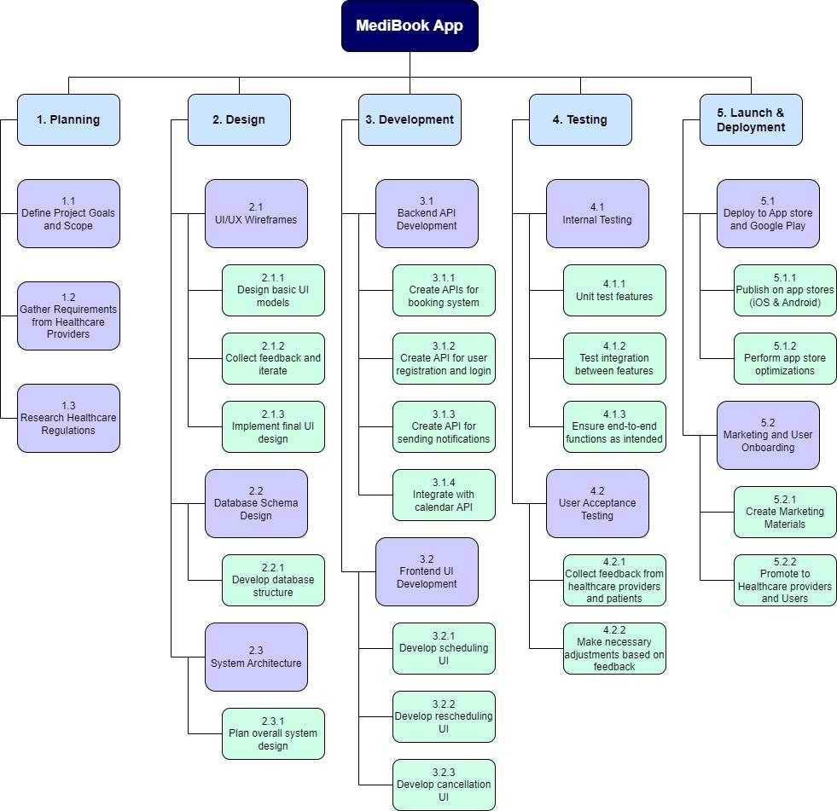

# 

# WBS DICTIONARY

| **WBS ID** | **Task Name** | **Description** | **Owner** |
| --- | --- | --- | --- |
| 1. **PLANNING** | | | |
| 1.1 | Define Project Goals and Scope | Identify and document key project objectives and scope. | Team Lead |
| 1.2 | Gather Requirements from Healthcare Providers | Collect needs from healthcare providers. | Research Team |
| 1.3 | Research Healthcare Regulations | Investigate compliance requirements. | Research Team |
| 1. **DESIGN** | | | |
| 2.1 | UI/UX Wireframes | Design user-friendly app screens and interface. | Designer |
| 2.1.1 | Design basic UI models | Create initial wireframes for the app interface. | Designer |
| 2.1.2 | Collect feedback and iterate | Review wireframes with stakeholders and revise. | Designer |
| 2.1.3 | Implement final UI design | Finalize and prepare the UI for development. | Designer |
| 2.2 | Database Schema Design | Design database tables and relationships for data storage. | Developer |
| 2.2.1 | Develop database structure | Create tables and relationships for storing data. | Database Engineer |
| 2.3 | System Architecture | Define the overall structure, modules, and technologies. | Lead Developer |
| 2.3.1 | Plan overall system design | Design technical architecture and infrastructure. | Lead Developer |
| 1. **DEVELOPMENT** | | | |
| 3.1 | Backend API development | Develop APIs for user authentication and booking. | Backend Developer |
| 3.1.1 | Create APIs for booking system | Build API endpoints for scheduling appointments. | Backend Developer |
| 3.1.2 | Create API for user registration and login | Develop user authentication endpoints. | Backend Developer |
| 3.1.3 | Create API for sending notifications | Develop endpoints for in-app and email notifications. | Backend Developer |
| 3.1.4 | Integrate with calendar API | Connect the booking system with calendar services. | Backend Developer |
| 3.2 | Frontend Development | Build the mobile app interface. | Developer |
| 3.2.1 | Develop scheduling UI | Create screens for booking appointments. | Frontend Developer |
| 3.2.2 | Develop rescheduling UI | Implement rescheduling functionality on the app. | Frontend Developer |
| 3.2.3 | Develop cancellation UI | Add options for canceling appointments. | Frontend Developer |
| 1. **TESTING** | | | |
| 4.1 | Internal Testing | Conduct functional and integration testing. | QA Tester |
| 4.1.1 | Unit test features | Test individual components and modules. | QA Tester |
| 4.1.2 | Test integration between features | Ensure compatibility between modules. | QA Tester |
| 4.1.3 | Ensure end-to-end functions as intended | Test full user workflows and app behavior. | QA Tester |
| 4.2 | User Acceptance Testing | Gather feedback from end-users and adjust the app. | QA Tester |
| 4.2.1 | Collect feedback from healthcare providers and patients | Conduct surveys and usability tests. | QA Tester |
| 4.2.2 | Make necessary adjustments based on feedback | Implement updates based on feedback. | Development Team |
| 1. **LAUNCH & DEPLOYMENT** | | | |
| 5.1 | Deploy to App Store and Google Play | Publish the app for users on iOS and Android. | Developer |
| 5.1.1 | Publish on app stores (iOS & Android) | Complete submission and review processes. | Developer |
| 5.1.2 | Perform app store optimizations | Optimize app descriptions, keywords, and visuals. | Marketing Team |
| 5.2 | Marketing & Onboarding | Promote app and provide user training. | Marketing Team |
| 5.2.1 | Create Marketing Materials | Develop ads, videos, and promotional content. | Marketing Team |
| 5.2.2 | Promote to Healthcare providers and Users | Conduct outreach campaigns and webinars. | Marketing Team |